**Core Components**

* **Tables** – a collection of items
  + DynamoDB stores data in a table, which is a collection of data.
  + Are schemaless.
  + There is an initial limit of 256 tables per region.
* **Items** – a collection of attributes
  + DynamoDB uses **primary keys** to uniquely identify each item in a table and **secondary indexes** to provide more querying flexibility.
  + Each table contains zero or more items.
* **Attributes**– a fundamental data element
  + DynamoDB supports nested attributes up to 32 levels deep.
* **Primary Key**– uniquely identifies each item in the table, so that no two items can have the same key. Must be scalar.
  + **Partition key** – a simple primary key, composed of one attribute.
  + **Partition key and sort key** (*composite primary key*) – composed of two attributes.
  + DynamoDB uses the partition key value as input to an internal hash function. The output from the hash function determines the partition in which the item will be stored. All items with the same partition key are stored together, in sorted order by sort key value. If no sort key is used, no two items can have the same partition key value.
* **Secondary Indexes**– lets you query the data in the table using an alternate key, in addition to queries against the primary key.
  + You can create one or more secondary indexes on a table.
  + Two kinds of indexes:
    - **Global secondary index** – An index with a partition key and sort key that can be different from those on the table.
    - **Local secondary index** – An index that has the same partition key as the table, but a different sort key.
  + You can define up to 20 global secondary indexes and 5 local secondary indexes per table.
* **DynamoDB Streams**– an optional feature that captures data modification events in DynamoDB tables.
  + The naming convention for DynamoDB Streams endpoints is *streams.dynamodb..amazonaws.com*
  + Each event is represented by a *stream record*, and captures the following events:
    - A new item is added to the table: captures an image of the entire item, including all of its attributes.
    - An item is updated: captures the “before” and “after” image of any attributes that were modified in the item.
    - An item is deleted from the table: captures an image of the entire item before it was deleted.
  + Each stream record also contains the name of the table, the event timestamp, and other metadata.
  + Stream records are organized into groups, or ***shards***. Each shard acts as a container for multiple stream records, and contains information required for accessing and iterating through these records.
  + Stream records have a lifetime of 24 hours; after that, they are automatically removed from the stream.
  + You can use DynamoDB Streams together with AWS Lambda to create a *trigger*, which is a code that executes automatically whenever an event of interest appears in a stream.
  + DynamoDB Streams enables powerful solutions such as data replication within and across Regions, materialized views of data in DynamoDB tables, data analysis using Kinesis materialized views, and much more.

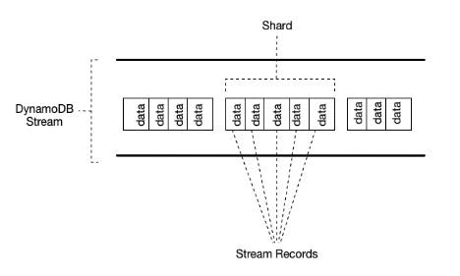

**Data Types for Attributes**

* **Scalar Types** – A scalar type can represent exactly one value. The scalar types are number, string, binary, Boolean, and null. Primary keys should be scalar types.
* **Document Types** – A document type can represent a complex structure with nested attributes—such as you would find in a JSON document. The document types are list and map.
* **Set Types** – A set type can represent multiple scalar values. The set types are string set, number set, and binary set.